Z5338602

Chunning Tu

IT Project

# Purpose Statement

The main purpose of the project is to help school staff and students to interact more convenient and flexibly, by creating a responsive website and app for them to use. This will help students in different campuses to communicate and develop better.

# WBS

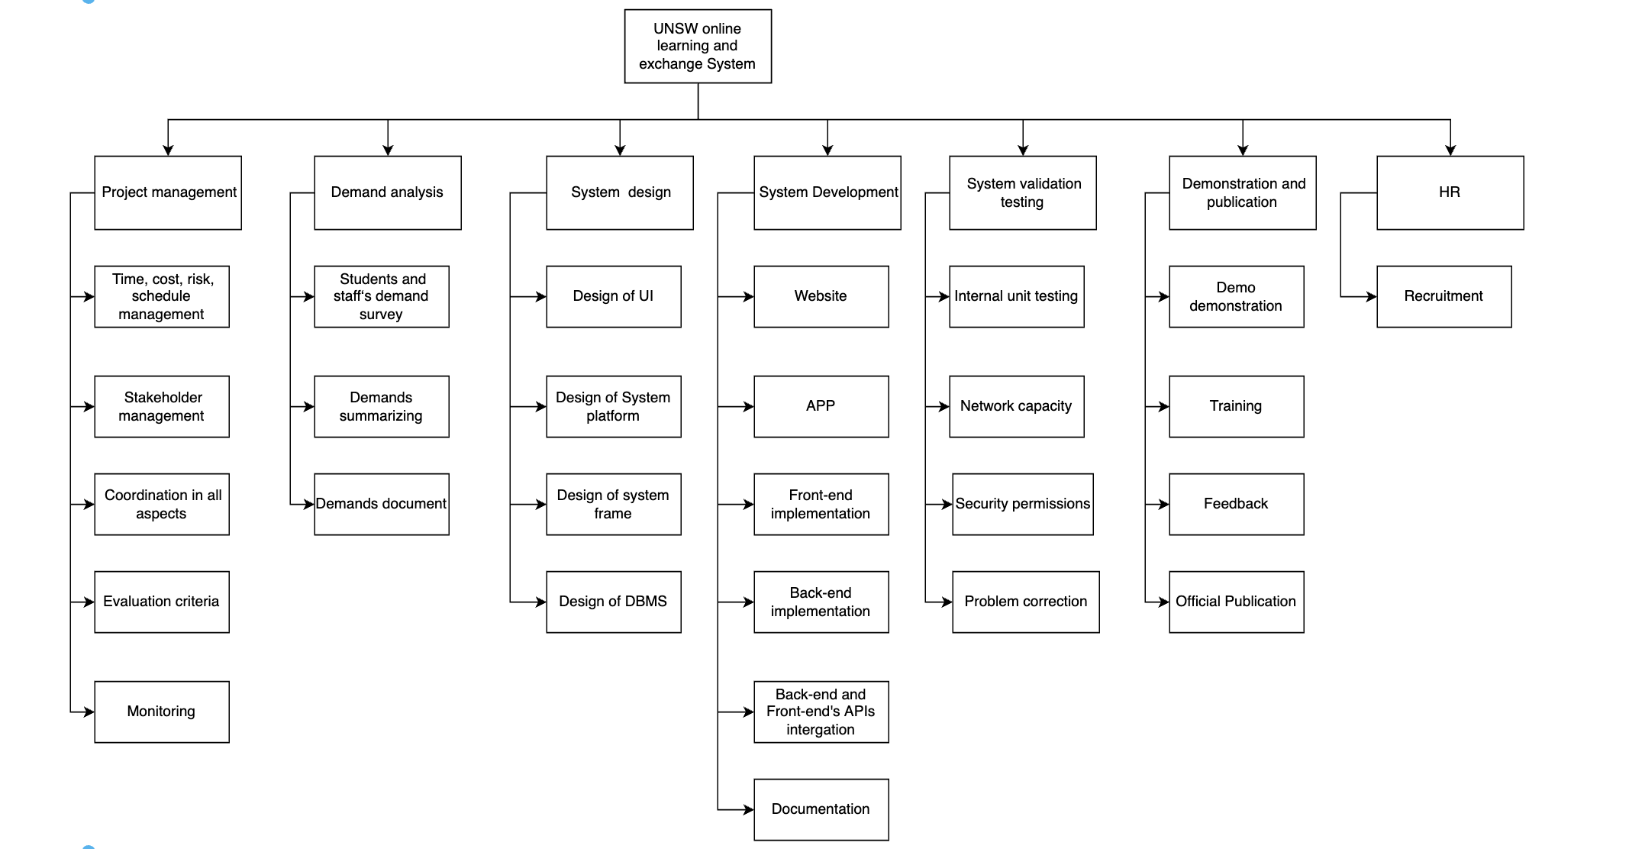

# Scope Statement

This program involves the formation of offering study groups based on location and courses, language learning and presentation practice, career development communication between students and industry recruiters. This needs to be achieved under AUD $2,000,000 that start from September 30th, 2022 to March 30th, 2023.

The project will incorporate appropriate user survey to consider the most appropriate network configuration like network capacity and access rights. Guided evaluation will be conducted to consider that there will be no delay when the user uses it, the user can only access with the permissions, the UI is beautiful, system validation testing to successfully demonstrate to the project sponsor and be used.